HW7 George Staples

**P1-**

https://georgest347.github.io/MATH-5620/softwareManual/HW7/heatEE1D

https://georgest347.github.io/MATH-5620/softwareManual/HW7/g1

https://georgest347.github.io/MATH-5620/softwareManual/HW7/g2

This code was used to solve the steady state temperatures of a rod with fixed temperatures at the ends. The table below shows the final temperatures for the given inputs.

Inputs:

X(t,0)=20;

X(t,L)=100;

X(0,x)=25;

L=10;

Final time =2;

k=10;

dt=0.001;

dx=1.0;

|  |  |  |  |  |  |  |  |  |  |  |
| --- | --- | --- | --- | --- | --- | --- | --- | --- | --- | --- |
| 20 | 26.0806 | 32.3471 | 38.9681 | 46.0784 | 53.7665 | 62.0647 | 70.9459 | 80.3249 | 90.0669 | 100 |

A contour plot shown below provides a visual representation of how the rod temperatures change with time. Plots for each of the subsequent problems were generated, but no noticeable changes were observed, therefore numerical data for the t=2 values will be compared.

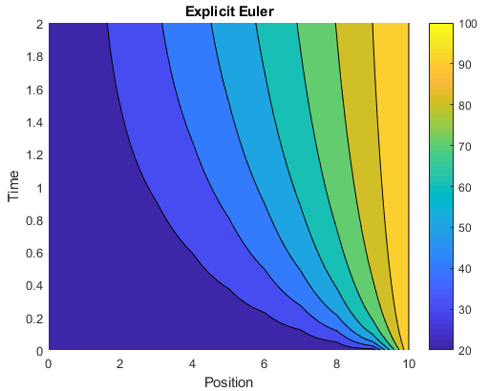

**P2-**

https://georgest347.github.io/MATH-5620/softwareManual/HW7/heatIE1D

https://georgest347.github.io/MATH-5620/softwareManual/HW7/g1

https://georgest347.github.io/MATH-5620/softwareManual/HW7/g2

This code was used with the same inputs as problem 1. The final temperatures are given in the table below:

|  |  |  |  |  |  |  |  |  |  |  |
| --- | --- | --- | --- | --- | --- | --- | --- | --- | --- | --- |
| 20 | 26.0771 | 32.3404 | 38.9587 | 46.0673 | 53.7545 | 62.0531 | 70.9359 | 80.3176 | 90.063 | 100 |

The Implicit Euler method is an under approximation compared to the Explicit Euler method. The two methods get similar results for a dt of 0.001 and dx of 1.

**P3-**

The following table shows how the dt affects the results of the Implicit Euler method.

|  |  |  |  |  |  |  |  |  |  |  |  |
| --- | --- | --- | --- | --- | --- | --- | --- | --- | --- | --- | --- |
| dt |  |  |  |  |  |  |  |  |  |  |  |
| 10^-3 | 20 | 26.0771 | 32.3404 | 38.9587 | 46.0673 | 53.7545 | 62.0531 | 70.9359 | 80.3176 | 90.063 | 100 |
| 10^-2 | 20 | 26.0615 | 32.3104 | 38.9168 | 46.0171 | 53.7008 | 62.0011 | 70.8909 | 80.2844 | 90.0454 | 100 |
| 10^-1 | 20 | 25.9127 | 32.0234 | 38.513 | 45.5296 | 53.173 | 61.4847 | 70.4405 | 79.9508 | 89.8678 | 100 |

As the dt goes closer to 0 the solution produced by the Implicit Euler method gets farther from the actual solution. The Accuracy goes down.

**P4-**

https://georgest347.github.io/MATH-5620/softwareManual/HW7/g1

https://georgest347.github.io/MATH-5620/softwareManual/HW7/g2

https://github.com/georgest347/MATH-5620/blob/master/softwareManual/HW7/heatPC.md

https://github.com/georgest347/MATH-5620/blob/master/softwareManual/HW7/functInital.md

Using the modified Predictor Corrector method from HW 5 and the same input values as P1 and P2, the function yielded:

|  |  |  |  |  |  |  |  |  |  |  |
| --- | --- | --- | --- | --- | --- | --- | --- | --- | --- | --- |
| 20 | 26.0788 | 32.3438 | 38.9634 | 46.0728 | 53.7605 | 62.0589 | 70.9409 | 80.3212 | 90.0649 | 100 |

These results are similar to those of the Implicit and Explicit Euler methods. Since the Explicit Euler method tends to over predict the values and the Implicit Euler under predicts, the PC method should be closer to the exact solution.

**P5-**

https://georgest347.github.io/MATH-5620/softwareManual/HW7/g1

https://georgest347.github.io/MATH-5620/softwareManual/HW7/g2

https://github.com/georgest347/MATH-5620/blob/master/softwareManual/HW7/heatRK4.md

https://github.com/georgest347/MATH-5620/blob/master/softwareManual/HW7/functInital.md

Using the RK4 function which was modified with method of lines, the following data was collected using the same input values as in problem 1.

|  |  |  |  |  |  |  |  |  |  |  |
| --- | --- | --- | --- | --- | --- | --- | --- | --- | --- | --- |
| 20 | 26.0791 | 32.3443 | 38.9642 | 46.0738 | 53.7615 | 62.0599 | 70.9417 | 80.3219 | 90.0652 | 100 |

The time step needed to run the RK4 method must satisfy the following equation:

